|  |  |
| --- | --- |
| ASSIGNMENT 2  OUA Building IT Systems (CPT 111) | **The Night WATCH**    Paul Atkins | S3779053  Daniel Burke | S3795096  Paul McKercher | S3791201  Michael Seymour | S3040138  Lee Van Den Blink | S3792973 |

# Table of Contents

[1 Table of Contents 1](#_Toc22430048)

[2 Project Description 2](#_Toc22430049)

[3 The Team 3](#_Toc22430050)

[3.1 The Team 3](#_Toc22430051)

[4 Minimum Viable Features 7](#_Toc22430052)

[4.1 MVF 1: Graphics for the bridge 7](#_Toc22430053)

[4.1.1 MVF 1 - Description 7](#_Toc22430054)

[4.1.2 MVF 1 - Validation Testing 8](#_Toc22430055)

[4.2 MVF 2 - Dialogue puzzle 10](#_Toc22430056)

[4.2.1 MVF 2 - Description 10](#_Toc22430057)

[4.2.2 MVF 2 - Validation Testing 10](#_Toc22430058)

[4.3 MVF 3 - Console minigame puzzle 12](#_Toc22430059)

[4.3.1 MVF 3 - Description 12](#_Toc22430060)

[4.3.2 MVF 3 - Validation Testing 13](#_Toc22430061)

[4.4 MVF 4 - Story 14](#_Toc22430062)

[4.4.1 MVF 4 - Description 14](#_Toc22430063)

[4.4.2 MVF 4 - Validation Testing 17](#_Toc22430064)

[4.5 MVF 5 - Title Screen With Menu 18](#_Toc22430065)

[4.5.1 MVF 5 - Description 18](#_Toc22430066)

[4.5.2 MVF 5 - Validation Testing 18](#_Toc22430067)

[5 Project Estimation 0](#_Toc22430068)

[5.1 Jeff Reynolds Estimates 0](#_Toc22430069)

[5.1.1 Justification 0](#_Toc22430070)

[5.2 Paul McKercher Estimates 2](#_Toc22430071)

[5.2.1 Justification 2](#_Toc22430072)

[5.3 Paul Atkins Estimates 3](#_Toc22430073)

[5.3.1 Justification 3](#_Toc22430074)

[5.4 Michael Seymour Estimates 4](#_Toc22430075)

[5.4.1 Justification 4](#_Toc22430076)

[5.5 Daniel Burke Estimates 5](#_Toc22430077)

[5.5.1 Justification 5](#_Toc22430078)

[5.6 Lee Van den blink Estimates 6](#_Toc22430079)

[5.6.1 Justification 6](#_Toc22430080)

[6 Listing Technologies 7](#_Toc22430081)

[6.1 Godot 7](#_Toc22430082)

[6.1.1 GitHub 7](#_Toc22430083)

[6.1.2 Art Resources 7](#_Toc22430084)

[6.2 Collaborative workspaces 8](#_Toc22430085)

[6.3 Software and Tools 8](#_Toc22430086)

[6.4 Resources 9](#_Toc22430087)

[7 APPENDIX 10](#_Toc22430088)

[7.1 Extended Features 10](#_Toc22430089)

[7.1.1 EF 1 – Sound 10](#_Toc22430090)

[7.1.1.1 EF 1 - Description 10](#_Toc22430091)

[7.1.1.2 EF 1 - Validation Testing 10](#_Toc22430092)

[7.1.2 EF 2 – Extended Story 11](#_Toc22430093)

[7.1.2.1 Details 11](#_Toc22430094)

[7.1.2.2 Validation Testing 11](#_Toc22430095)

[7.1.3 EF 3 – Player movement 11](#_Toc22430096)

[7.1.3.1 Details 11](#_Toc22430097)

[7.1.3.2 Validation Testing 11](#_Toc22430098)

[7.1.4 Extended Feature 4 – Additional Rooms 12](#_Toc22430099)

[7.1.4.1 Details 12](#_Toc22430100)

[7.1.4.2 Extended Feature 4 - Validation Testing 12](#_Toc22430101)

[7.2 Artifact Documents 13](#_Toc22430102)

[7.2.1 Story files 13](#_Toc22430103)

[7.2.2 Dialogue puzzle example 13](#_Toc22430104)

[7.2.3 Sound concept document 13](#_Toc22430105)

[7.3 Todo: 13](#_Toc22430106)

[7.3.1 Start / finish dates for features 13](#_Toc22430107)

[7.3.2 Make resources pretty 13](#_Toc22430108)

# Project Description

Our product is a single-player game. The theme is space, set on a space ship, and in addition to the Player Character it involves three NPCs: an Engineer, a Pilot, and the ship's computer AI. The crew of the ship are alone in deep space, more than ten years from Earth on a mission to locate and destroy unstable planets, collect materials from destroyed planets, and explore uncharted regions. The plot was inspired by John Carpenter's movie Dark Star. The game is a 2D game with dialogue and console interaction puzzles. As the Captain, the Player Character must solve these puzzles in order to accomplish tasks and objectives. The main gameplay is interacting with the console and other crew members.

# The Team

|  |  |
| --- | --- |
| **Paul Andrew Atkins**  [s3779053@student.rmit.edu.au](mailto:s3779053@student.rmit.edu.au)  Trello ID @paulatkins28 |  |

I have been using computers since I could read. My father brought me a Walt Disney Basic book when I was approximately 5-6 and my interest grew from there. I enjoy coding as I still find it fascinating to build things with words, to create things with words, to help people with software. "To make the world a better place" (Silicon Valley).

My strong points would be OOP Languages, and whilst only proficient in Java at the moment I am teaching myself Python, JS, C#. I enjoy making systems that are adaptable to different situations (think game engine, CMS).

The challenge I face for this project is to learn GODOT engine and its scripting language which is similar to python, so yes, a challenge but a welcomed one.

I see myself contributing what coding knowledge I have next to some of the more experienced, the skills I have using game engines (unity, java). My limited sketching which can be used for low-fi mock-ups on a kanban board or similar.

I’m excited to get started.

|  |  |
| --- | --- |
| **Daniel Peter Burke**  [s3795096@student.rmit.edu.au](mailto:s3795096@student.rmit.edu.au)  Trello ID @danielburke63 |  |

First PC was an 8086, in 1986. Had every major model since. Started programming in C when I was 8, x86 assembly at 15, it all went downhill from there.

Currently interested in GPU programming (Vulkan, OpenCL, GL compute), high performance (memory alignment & layout, cache utilisation), threading, and dealing with sadistic levels of fault handling (I think Erlang is cool).

The challenge will be whittling this down to something we can complete.

Clearly, my art talents will be a big advantage, because MS Paint is the future. THE FUTURE. My professional work is usually gluing random stuff together, so I expect to be running around tying up loose ends.

|  |  |
| --- | --- |
| **Paul Stephen McKercher**  [s3791201@student.rmit.edu.au](mailto:s3791201@student.rmit.edu.au)  Trello ID @paulmck3 |  |

I am very passionate about the big picture of things. From the concept to the implementation and product. I have always been very comfortable with Hardware (have been building computers since I was 16 circa. 1998).

I am interested in what cutting-edge technology is doing to make our lives easier. I also find programming to be very rewarding when I create a workable practical program. I am new to OO programming but getting more experience every day.

With the two biggest challenges I foresee, one is working with a team who are possibly more comfortable than I am at coding/scripting a product. The other is trying to manage time with the group members and my erratic work schedule.

I feel I can most contribute with ideas and story for the program, also with concepts to improve this. I will also hope to edit/write scripting for the game.

|  |  |
| --- | --- |
| **Jeff Reynolds**  [s3775599@student.rmit.edu.au](mailto:s3775599@student.rmit.edu.au)  Trello ID @jeff44979415 |  |

I started programming in the 80's as a teenager, worked in IT from 1999 to current, with most of that time in IT projects, payments, finance industry. I've worked in a variety of roles, including product support, business analysis, and project management.

I'm an amateur programmer, with some experience in c++, java, lua, perl, visual basic (and vba), and sql databases. I've also dabbled in graphic design.

My strengths are creativity, writing, general IT knowledge, and industry experience.

My interests are in tech that removes hurdles, as an example things like tap payments. I also like developing products in the gaming and entertainment space. I'm passionate about creating good user experiences as for me this is the most fundamental aspect of a good product.

The challenges for me with this project will be working with an unfamiliar game engine and collaborating with a group on a purely creative project.

My main contributions will be coding and helping out with some project management practices.

|  |  |
| --- | --- |
| **Michael James Seymour**  [s3040138@student.rmit.edu.au](mailto:s3040138@student.rmit.edu.au)  Trello ID @michael79466379 |  |

Computers and IT have been the background noise of my life for as long as I can remember but I never looked to it as a serious pursuit until recently, as a means of a career change.

I've done some online coding courses and proved to myself that I have the ability to sit in one place trying to solve a coding challenge, sometimes for many hours without moving from my seat if that's what it takes. I have experience at writing basic code in Java, Python, C, HTML/CSS, SQL, Godot Game Engine, and to a lesser extent Lua and C++. I simply like coding challenges, regardless of the project theme.

My challenges in the context of the project are my lack of real-world experience in writing professional code, and my lack of real-world group experience. The only groups I have experience with are the groups I've worked with during this degree program.

My main contributions will be in coding, and writing characters & storylines. As I have some previous experience with Godot, I will be an advisor to other team members who will be using this game engine for the first time on this project.

|  |  |
| --- | --- |
| **Lee van den Blink**  [s3792973@student.rmit.edu.au](mailto:s3792973@student.rmit.edu.au)  Trello ID @leevandenblink |  |

I’ve always found myself adept at learning software and business IT structures. Working in small RTOs (Registered Training Organisations) gave me opportunity to learn about many areas of IT business structures, such as server administration, security and document management systems. Along with this I’ve worked with a number of student management systems (SMS) and Learning Management Systems (LMS) and have a lot of experience with data analysis and reporting, and I enjoy being able to use data to discover insight into a business. I’ve also always loved video games, and would love to one day be able to contribute to software or game development.

I believe my strengths are being a team player, data analysis and document formatting. I also have a beginner’s level of programming knowledge in Java through completing Intro to Programming and Programming 1. I am extremely interested in further developing my programming skills through learning a game engine, and increasing my overall programming knowledge.

The main challenge for myself in this project is that I’ve never done any game development before, except for developing game concepts, and some basic java applications. So, learning what actually goes into making a basic game with code, graphics and sound will be entirely new for me.

I would like to help develop the logical sequencing of the game, and have input into the various systems that work in the background. I want to ensure the various game play loops are logical, and fun. I also think I could assist in formatting work documents for our assignment reports.

# Minimum Viable Features

This section details the Minimum Viable Features (referred to as MVF) for The Night Watch. Extended features (referred to as EF) are [detailed in the appendix](#_Extended_Features).

## MVF 1: Graphics for the bridge

### Description

Gameplay takes place aboard a space ship. The game starts with the player on the ship’s bridge, where the console and two crew members (John and Barry) are visible.

The scene is displayed using four images, developed firstly as rough sketches, drafts, and subsequently using rotoscoping techniques that convert photos into images by using a light pen to capture details from the photograph.

The following design artifacts show the development of art assets through the design process.

Sketch Draft Rotoscoped image

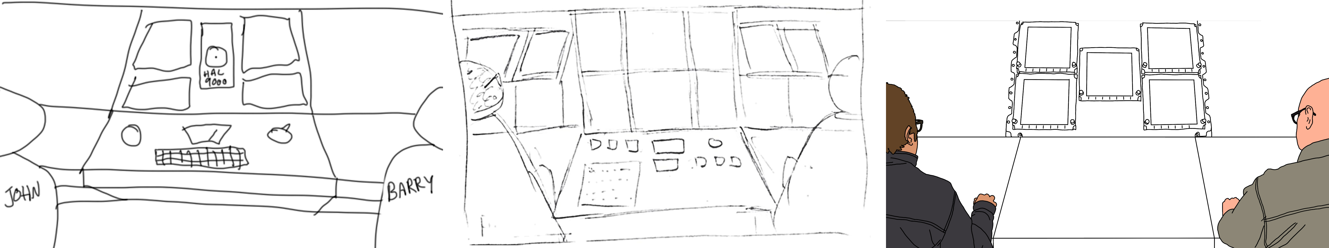

***Figure 1.*** *The main image showing the ship’s Console, with crew members John, and Barry seated. The player can choose to click on the console, John, or Barry.*

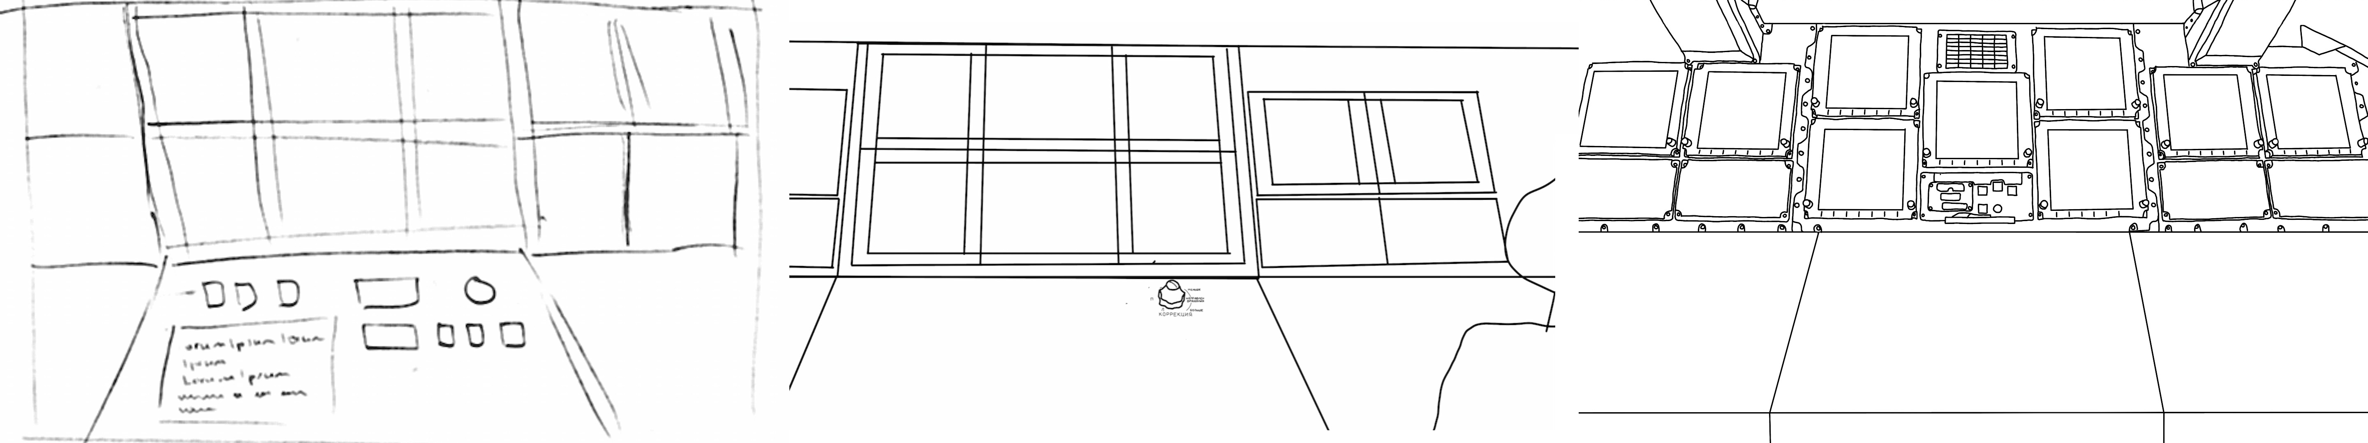

***Figure 2.*** *Console close-up, displayed after the player clicks on the console in the main image. The player can choose to return to the main image; or they can click on buttons/levers, which initiate the console minigame (see* [*MVF 3*](#_Core_Feature_3:)*).*

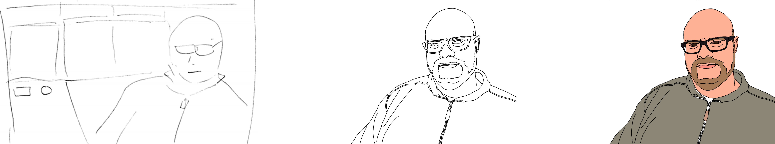

***Figure 3.*** *Barry close-up, displayed as part of a dialogue puzzle after the player clicks on Barry in the main image. The player interacts with the dialogue puzzle, after which they return to the main image.*

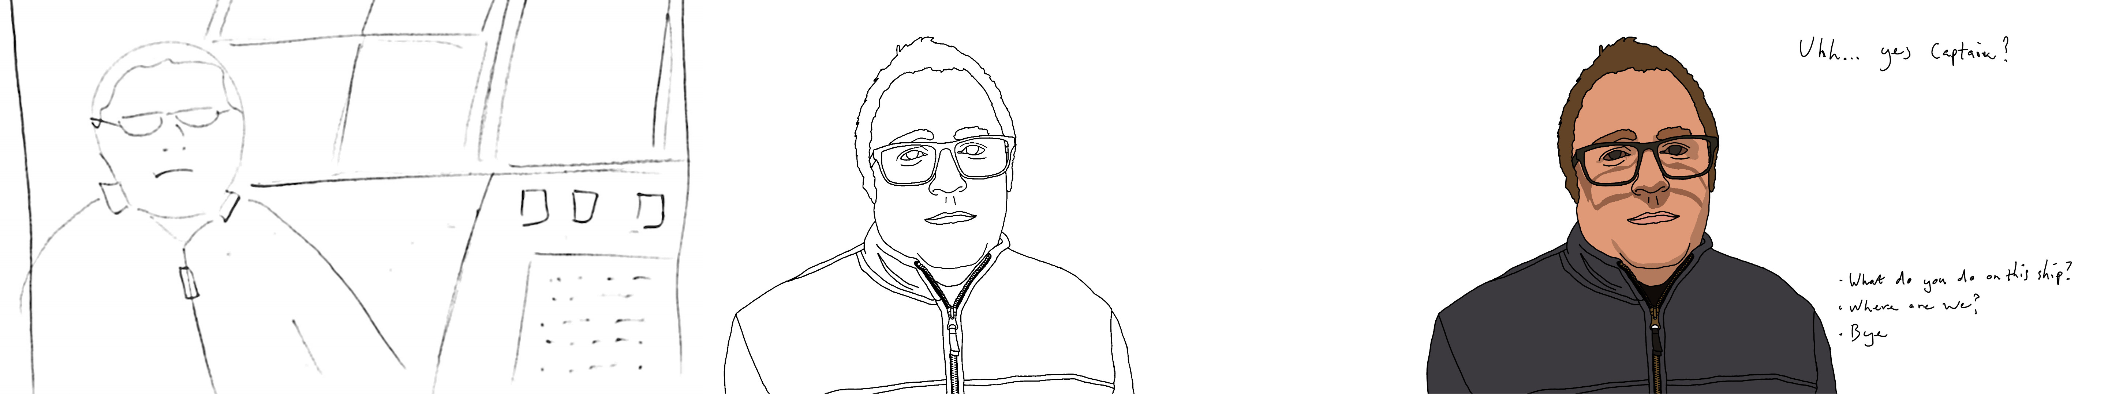

***Figure 4.*** *John close-up, which is displayed as part of a dialogue puzzle (see* [*MVF 2*](#_Minimum_Viable_Feature_1)*)after the player clicks on John in the main image. The player interacts with the dialogue puzzle, after which they return to the main image.*

### Validation Testing

| **#** | **Condition** | **Success** | **Failure** |
| --- | --- | --- | --- |
| 1 | After starting a new game | Main screen is displayed | Main screen is not displayed |
| 2 | After clicking the console from the main screen | Console close up is displayed | Console close up is not displayed |
| 3 | After clicking John from the main screen | John close up is displayed | John close up is not displayed |
| 4 | After clicking Barry from the main screen | Barry close up is displayed | Barry close up is not displayed |
| 5 | After exiting the console mini game | Main screen is displayed | Main screen is not displayed |
| 6 | After exiting John’s dialogue puzzle | Main screen is displayed | Main screen is not displayed |
| 7 | After exiting Barry’s dialogue puzzle | Main screen is displayed | Main screen is not displayed |
| 8 | After exiting the Title menu | Main screen is displayed | Main screen is not displayed |

**Authors:**

Sketches by Lee Van den blink and Daniel Burke, Rotoscoping by Daniel Burke

**Start Date:** { dd/mm/yyyy }

**Estimated Finish Date**: { dd/mm/yyyy }

## MVF 2 - Dialogue puzzle

### Description

**Updated since proposal**: Originally only one dialogue puzzle was planned, this has been expanded to two (see [EF 2](#_Extended_Feature_2_1))

Through dialogue puzzles, the player can negotiate with the two crew members to help solve the problem with the ship’s console. There are two dialogue puzzles, one with John and one with Barry. A dialogue puzzle is initiated when the player clicks the relevant crew member in the main image (see [MVF 1](#_Minimum_Viable_Feature)).

Each puzzle with a crew member’s initial dialogue being displayed, along with a series of responses that the player can select to respond with (example below). Selecting a response results in further dialogue being displayed, and additional responses. By working through the tree of dialogue options, and by selecting certain choices, the console mini game puzzle is made easier for the player. (See video example in [appendix documents](#_Appendix_Documents))

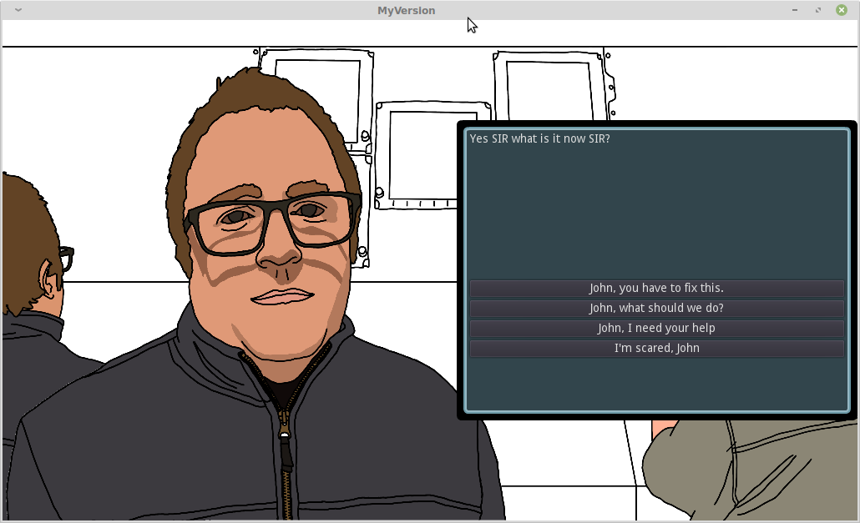

***Figure 5.***  *The player initiating John’s dialogue puzzle*

### Validation Testing

Dialogue files (design artifacts) are included in the [appendix](#_Appendix_Documents), and validation testing is performed against the content of these files.

| **#** | **Condition** | **Success** | **Failure** |
| --- | --- | --- | --- |
| 1 | After initiating Barry’ dialogue puzzle | The player is presented with the first tier of responses | The player is not presented with the first tier of responses |
| 2 | (New condition for [EF 2](#_Extended_Feature_2_1))  After initiating John’s dialogue puzzle | The player is presented John’s initial dialogue | The player is not presented with John’s initial dialogue |
| 3 | After selecting a response | The player is presented with John’s subsequent dialogue | The player is not presented with the subsequent dialogue |
| 4 | After selecting a response | The player is presented with the subsequent tier of responses | The player is not presented with the subsequent tier of responses |
| 5 | (New condition for [EF 2](#_Extended_Feature_2_1))  After successfully completing one dialogue puzzle (success is defined in the dialogue file) | The difficulty of the console minigame is reduced to medium | The difficulty of the console minigame is either hard or easy. |
| 6 | After successfully completing two dialogue puzzles (success is defined in the dialogue file) | The difficulty of the console minigame is reduced to easy | The difficulty of the console minigame is either hard or medium. |

**Author:** Michael Seymour

**Start Date:** dd/mm/yyyy

**Estimated Finish Date:** dd/mm/yyyy

## MVF 3 - Console minigame puzzle

### Description

The console has screens that each display something odd – text is in russian, there is a picture of Red Square, and a bear holding an AK47.

**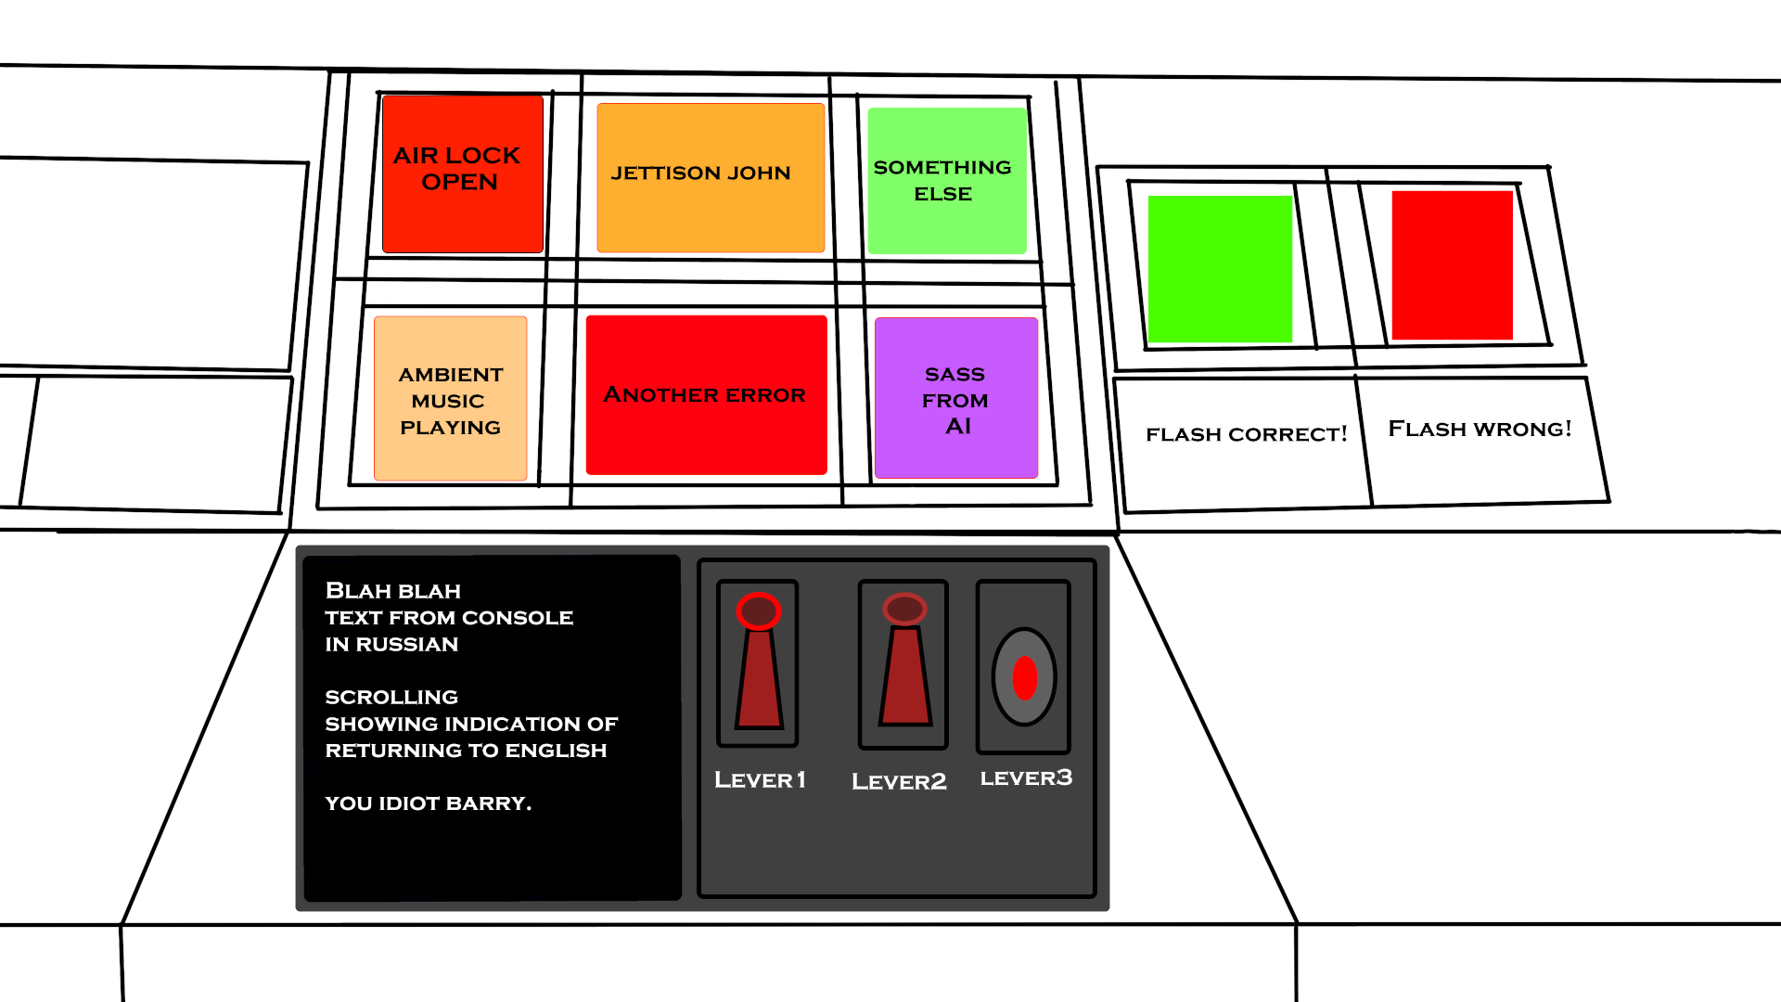**

***Figure 6.*** *A concept image (design artifact) used to develop the console minigame puzzle*

The console minigame game involves trying combinations of levers and buttons, to try and revert monitors back to the way they should be. Along the way, different combinations give funny results like playing music or ejecting Barry.

In technical terms, there will be 16 lever and button combinations, and each will produce a different state of screens.

The console puzzle has are three levels of difficulty, which is determined by the outcomes of dialogue with Barry and John.

**Update:** Originally only one dialogue puzzle was included, however this has since been expanded to two (See [EF 2](#_Extended_Feature_2_1)) which impacted this feature. By adding an addiotional dialogue puzzle, a new requirement has been introduced to reduce the difficulty of the console minigame puzzle after the new dialogue puzzle is completed. Test conditions for this requirement are documented in [MVF 2](#_Minimum_Viable_Feature_1).

* **Hard** means all monitors are displaying incorrectly.
* **Medium** means 1 monitors is displaying correctly.
* **Easy** means 2 monitors are displaying correctly.

(For each of the two *dialogue* *puzzles* the player successfully completes - see MVF2, a monitor is reverted)

*Sadly, it will not be possible to solve Barry’s dialogue puzzle if he has been ejected from the ship.*

When all monitors are reverted, an outro dialogue is shown. This dialogue is one of two possible endings, depending on whether the player won the game with assistance from either Barry or John, or whether the player won the puzzle entirely by themselves. After this final dialogue, the game ends.

### Validation Testing

| **#** | **Condition** | **Success** | **Failure** |
| --- | --- | --- | --- |
| 1 | After the player clicks a button or lever | A screen changes | No screens change |
| 2 | The button and lever combination matches the defined combination for Barry being ejected | Barry is ejected | Barry is not ejected |
| 3 | The button and lever combination matches the defined combination for the game to end | The end sequence is initiated | The end sequence is not initiated |

**Author:** Michael Seymour, Paul Atkins

**Start Date:** dd/mm/yyyy

**Estimated Finish Date:** dd/mm/yyyy

## MVF 4 - Story

### Description

The game uses a story to outline the characters and aims of the player character, and provides the flow for the game.

The story is told through narrative text, dialogue puzzles, and the console mini-game – and includes two possible endings based on choices the player makes while playing.

**Update since proposal:** The original story included anchor’s for dialogue with the ship’s AI, this has since been descoped.

**Update since proposal:** The original story included one dialogue puzzle, this has been expanded to two (See [EF 2](#_Extended_Feature_2_1))

Below is the story outline (design artifacts) which serves as an introduction in the game, as well as a concept diagram that has been used to tie the story to the game’s interactions. See [appendix](#_Appendix_Documents) for the complete story outline, including anchors to game elements.

|  |
| --- |
| *The Night Watch*  *On a long-range scouting mission into deep space, the crew of the Australian National Astrophysics League deep space reconnaissance frigate ‘Bon Scott’ are a long way from a hot shower. Their mission: to patrol the galaxy looking for unstable planets to destroy, trailblazing the way for mineral harvest ships following them some years behind. Lieutenant Thoroughfare, Third Officer, commands the Night Watch.*  *Lieutenant James (“Jim”) Thoroughfare has heard all the jokes now about it always being night in deep space, and the edge really wore off when it became clear that "it's always night" came to be a convenient excuse for him and his team to be summoned to respond to any unpleasant shipboard matters.*  *Captain has a sniffle? Night Watch pulls a double shift. The heads are overflowing after another 'saveloy Saturday'? Grab your buckets and fishing waders, Night Watch, it’s going to get messy. Someone left the reactor core safety hatch open? Hope you brought some sunscreen, looks like Night Watch are getting a nice tan this week.*  *Pilot Barry thought commanding a frigate with the power to destroy a planet would be a dream job, but after the first week he realised that most of space is a lot of empty space, and piloting doesn't require very much manoeuvring. After ten years he's lost count of the number of time he's wished he'd brought a good book.*  *Engineer John graduated top of his university course. He went on to complete a master’s degree in advanced quantum propulsion systems in less than a year. He was headhunted by the Australian National Astrophysics League and was the first choice in every round of panel interviews. He was assigned to the Rasputin and assured that it was the first step in a what was sure to be a prestigious career.*  *That was approximately two months before Dr Kermit Ferguson made his famous breakthrough in computer AI systems, successfully developing the first sentient computer AI which, despite countless testing, never failed a Turing test. The League was an early adopter of this technology and its flagship UNN Rasputin was the first of the fleet to have a fully sentient computer AI monitoring system installed.*  *Engineer John's years of expertise and training were rendered obsolete immediately and his role was reduced to requesting the computer AI do what he had spent his entire life training to do. As a result, John harbours some resentment towards the computer, the League, and most sentient life in general.*  *It's a typical night for the Night Watch. Lieutenant Thoroughfare has just come on duty and begins the usual watch checks with Pilot Barry and Engineer John.*  *Due to an attempt to learn Russian in his vastly spare, Barry has managed to change the highly sophisticated computer AI's interface to Russian, which none of the crew understand. Consequently, the crew don't know how to change this back. They also soon find that as well as changing the language interface, the computer AI's personality has adopted that of a surly, short-tempered Slavic babushka.*  *However, it's the Night Watch, and surely tonight can't be worse than the aftermath of the last 'saveloy Saturday' (John still can't look at a bowl of muesli without turning green). The mission must continue.*  *Lieutenant Thoroughfare must convince, cajole, and negotiate with his crew - and the computer - in order to change the console back into English before the Morning Watch crew find out what’s happened.*  *Lieutenant Jim Thoroughfare approaches the bridge for the start of the Night Watch.*  *Now PC has a choice in talking to Barry more, talking to John or talking to the console.*  *Player decides next path* |

**Figure 7.** Story outline (design artifact)

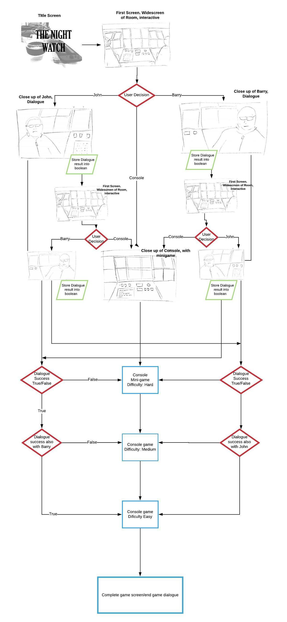

***Figure 8.*** *A concept diagram (design artifact) showing the flow of the story within the context of the game.*

### Validation Testing

| **#** | **Condition** | **Success** | **Failure** |
| --- | --- | --- | --- |
| 1 | After the player starts a new game | The introduction narrative is displayed | The introduction narrative is not displayed |
| 2 | After the player starts a new game | Graphics setting the scene of a space ship’s bridge are displayed | Graphics setting the scene of a space ship’s bridge are not displayed |
| 3 | After the player starts a new game | Dialogue puzzles with crew can be initiated | Dialogue puzzles with crew cannot be initiated |
| 4 | [DESCOPED] ~~After the player starts a new game~~ | ~~Dialogue puzzles with ship’s AI can be initiated~~ | ~~Dialogue puzzles with ship’s AI cannot be initiated~~ |
| 5 | After the player completes the game | End game cutscene is displayed | End game cutscene is not displayed |
| 6 | After the player completes the game via path 1 | The epilogue narrative for path 1 is displayed | The epilogue narrative for path 1 is not displayed |
| 7 | After the player completes the game via path 2 | The epilogue narrative for path 2 is displayed | The epilogue narrative for path 2 is not displayed |

**Authors:** Michael Seymour,Paul McKercher

**Start Date:** dd/mm/yyyy

**Esimtated Finish Date:** dd/mm/yyyy

## MVF 5 - Title Screen With Menu

### Description

**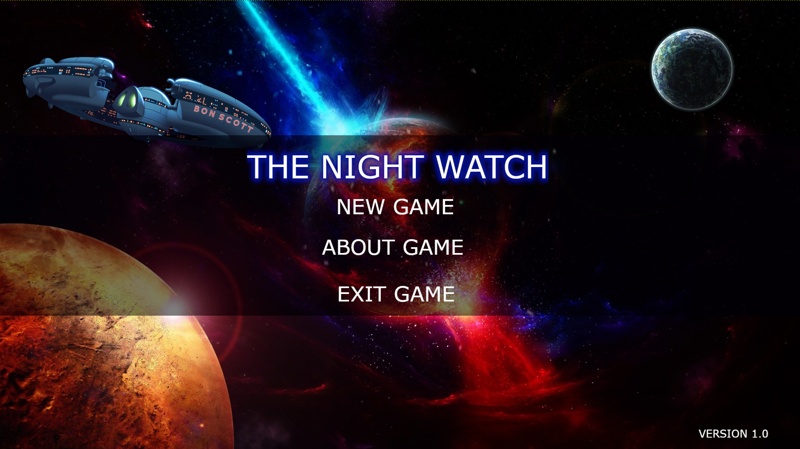**

***Figure 9.*** *Mock up of title screen with menu (design artifact)*

The game has a title screen that is displayed when first loaded. From the title screen, the player may choose to start a new game, read about the game, or exit the game.

The title screen incldues a space backdrop, the the space ship ‘Bon Scott’, and the menu options themselves.

When the player selects a menu option, the game behaves accordingly:

* New game starts a new game
* About game displays information about the game
* Exit game closes the game application

### Validation Testing

| **#** | **Condition** | **Success** | **Failure** |
| --- | --- | --- | --- |
| 1 | After the player loads the game | The title screen and menu is displayed | The title screen and menu is not displayed |
| 2 | After the player chooses New Game | The introduction narrative is displayed | The introduction narrative is not displayed |
| 3 | After the player chooses About Game | Information about the game is displayed | Information about the game is not displayed |
| 4 | After the player chooses Exit Game | The game application closes | The game application does not close |

**Author:** Paul McKercher, Jeff Reynolds

**Start Date:** dd/mm/yyyy

**Estimated Finish Date:** dd/mm/yyyy

# Project Estimation

|  |  |  |  |  |  |  |  |  |
| --- | --- | --- | --- | --- | --- | --- | --- | --- |
|  |  | | | | | | |  |
|  | **Estimated by** | | | | | | |  |
| **Feature** | **Sarah Longhurst** | **Jeff Reynolds** | **Paul McKercher** | **Paul Atkins** | **Michael Seymour** | **Daniel Burke** | **Lee van den Blink** | **Average Hours** |
| MVF 1 - Graphics for 1 Room | 33 | 41 | 27 | 21 | 45 | 30 | 53 | 36 |
| MVF 2 - Dialog puzzles | 28 | 51 | 32 | 37 | 32 | 15 | 48 | 35 |
| MVF 3 - Console mini game puzzle | 40 | 46 | 34 | 67 | 70 | 27 | 43 | 47 |
| MVF 4 - Story | 32 | 71 | 17 | 27 | 16 | 22 | 37 | 32 |
| MVF 5 - Title Screen with Menu | 18 | 14 | 20 | 23 | 42 | 27 | 19 | 23 |
| EF 1 -Sound & Music | 30 | 39 | 34 | 8 | 10 | 30 | 12 | 23 |
| EF 2 - Extended Story | 21 | 31 | 24 | 17 | 22 | 21 | 21 | 22 |
| EF 3 - Ability to Walk | 28 | 99 | 44 | 22 | 45 | 60 | 23 | 46 |
| EF 4 - Additional Rooms | 45 | 38 | 34 | 18 | 70 | 38 | 25 | 38 |
|  |  |  |  |  |  |  | **Total:** | 302 |

## Jeff Reynolds

### Estimates

|  |  |  |  |  |  |  |
| --- | --- | --- | --- | --- | --- | --- |
| **Feature** | **Research** | **Learning** | **Designing** | **Coding** | **Testing** | **Total Hours** |
| MVF 1 - Graphics for 1 Room | 5 | 5 | 15 | 10 | 6 | **41** |
| MVF 2 - Dialog puzzles | 2 | 10 | 15 | 15 | 9 | **51** |
| MVF 3 - Console mini game puzzle | 2 | 5 | 10 | 20 | 9 | **46** |
| MVF 4 - Story | 2 | 0 | 60 | 0 | 9 | **71** |
| MVF 5 - Title Screen with Menu | 1 | 4 | 2 | 4 | 3 | **14** |
| EF 1 -Sound & Music | 5 | 2 | 8 | 15 | 9 | **39** |
| EF 2 - Extended Story | 0 | 0 | 25 | 0 | 6 | **31** |
| EF 3 - Ability to Walk | 10 | 5 | 65 | 10 | 9 | **99** |
| EF 4 - Additional Rooms | 5 | 2 | 15 | 10 | 6 | **38** |
| **Totals** | **32** | **33** | **215** | **84** | **66** | **430** |

### Justification

My estimates are higher than some of the others as I have learned to be conservative with estimates. I find it is common for people to estimate the time it takes to perform a discrete task, and not factor in all of the ancillary time that goes with the task – discussion, inspiration, etc, resulting in low estimates.

* Research I considered as either watching the dark star film, searching for reference material (art/sound), or watching various tutorials.
* Learning I considered as learning the game engine, or tools required to perform a task (e.g. gimp for graphics)
* Designing is where the bulk of the work occurs, as it's important to know what you are building before you start building. A lot of the time I have included in design factors in "group think". For example we spent a number of hours discussing story options with the group, which when you include 6 people's time adds up very quickly.
* Coding times reflect the expected complexity of implementation.
* Testing times assume all team members will perform testing, and so 6 total = 1 hour budgeted for each person.

**MVF 1 - Graphics for 1 Room**

Research needs to locate reference material, and drawing methods learned (rotoscoping). The bulk of the time is spent designing and implementing scenes. Allocation of 6 hours testing = 1 hour per team member.

**MVF 2 - Dialog puzzles**

Dialogue puzzles are common in games, so only enough research to understand patterns. Learning is for game engine, the bulk of the time is spent designing and coding, with 1.5 hours allocated to testing for each team member.

**MVF 3 - Console mini game puzzle**

Research in the form of tutorials, 5 hours allocated to learn game engine, 10 hours designing the puzzle, and then 20 hours to solve implementation. 1.5 hours allocated to testing for each team member.

**MVF 4 - Story**

Research is watching the dark star film (inspiration for game), designing is all of the discussions leading up to and including defining the setting, narrative, and overall dialogue. Testing is review, with 1.5 hours allocated to each team member.

**MVF 5 - Title Screen with Menu**

Research required in the form of tutorial vids, learning for game engine, design is straightforward, and coding should be fairly simple. 30 minutes testing allocated to each team member.

**EF 1 - Sound & Music**

Research is locating suitable sounds, learning for game engine, designing is identifying sound triggers within the game, coding time spent attaching triggers and 1.5 hours allocated to each team member for testing.

**EF 2 - Extended Story**

No research or learning, 25 hours allocated to design but this is very ambigious with no defined scope.

**EF 3 - Player Character - Ability to Walk**

The game is designed to be displayed from the player's perspective, adding ability to walk means adding a player character and redesigning several MVF’s. Due to this flow on effect, it has significant design requirements.

**EF 4 - Additional Rooms**

Each additional room has slightly less effort than the first room (MVF 1), but similar work is required to MVF 1.

## Paul McKercher

### Estimates

|  |  |  |  |  |  |  |
| --- | --- | --- | --- | --- | --- | --- |
| **Feature** | **Research** | **Learning** | **Designing** | **Coding** | **Testing** | **Total Hours** |
| MVF 1 - Graphics for 1 Room | 4 | 8 | 10 | 4 | 1 | **27** |
| MVF 2 - Dialog puzzles | 2 | 8 | 6 | 6 | 10 | **32** |
| MVF 3 - Console mini game puzzle | 8 | 8 | 8 | 8 | 2 | **34** |
| MVF 4 - Story | 1 | 1 | 10 | 3 | 2 | **17** |
| MVF 5 - Title Screen with Menu | 4 | 4 | 2 | 8 | 2 | **20** |
| EF 1 -Sound & Music | 8 | 6 | 12 | 4 | 4 | **34** |
| EF 2 - Extended Story | 0 | 0 | 10 | 10 | 4 | **24** |
| EF 3 - Ability to Walk | 8 | 12 | 8 | 8 | 8 | **44** |
| EF 4 - Additional Rooms | 2 | 4 | 12 | 12 | 4 | **34** |
| **Totals** | **37** | **51** | **78** | **63** | **37** | **266** |

### Justification

* I believe the Dialog and Story MVF's would be the most time consuming because you would have to be creative and come up with story beats. Dialog also requires some creativity.
* In terms of stages, I believe Designing and Coding stages would take the longest duration.
* Designing graphics, puzzles, all that is time consuming.
* Coding could be a massive time sink. Whilst all of us have some coding skills, applying them to a new engine and Gdscript will require trial and error.
* I believe the Dialog puzzle is time consuming in two ways. Initially drafting the text and then creating a dialog system in Godot with branches and returns to the main dialog tree. I expect this to be quite tricky.
* The EVF Ability to walk will take a huge amount of time because it would be adding a new element to the gameplay/interaction. Currently we expect the interaction to be clickable, but changes that to a walking animation between different parts of the ship adds a whole new layer of complexity. First with the walking animations and secondly with the interaction with different screens.
* Learning Godot and GDScript will be time consuming also.

## Paul Atkins

### Estimates

|  |  |  |  |  |  |  |
| --- | --- | --- | --- | --- | --- | --- |
| **Feature** | **Research** | **Learning** | **Designing** | **Coding** | **Testing** | **Total Hours** |
| MVF 1 - Graphics for 1 Room | 3 | 3 | 5 | 8 | 2 | **21** |
| MVF 2 - Dialog puzzles | 5 | 10 | 10 | 10 | 2 | **37** |
| MVF 3 - Console mini game puzzle | 5 | 30 | 10 | 20 | 2 | **67** |
| MVF 4 - Story | 5 | 5 | 10 | 5 | 2 | **27** |
| MVF 5 - Title Screen with Menu | 2 | 6 | 4 | 10 | 1 | **23** |
| EF 1 -Sound & Music | 2 | 2 | 2 | 1 | 1 | **8** |
| EF 2 - Extended Story | 4 | 2 | 4 | 5 | 2 | **17** |
| EF 3 - Ability to Walk | 4 | 2 | 10 | 5 | 1 | **22** |
| EF 4 - Additional Rooms | 2 | 4 | 4 | 6 | 2 | **18** |
| **Totals** | **32** | **64** | **59** | **70** | **15** | **240** |

### Justification

* Research done for the first room was done through sourcing NASA pictures and real life model sketching onto a tablet.
* I have allocated the drawing hours in the coding column.
* Dialog puzzles required sourcing an open source dialog engine as the time frame we have didnt allow the creatation of our own.
* The mini-game will require doing godot tutorials to learn how to setup the requirements needed to implement our plan for the mini-game.
* The story is short and funny with most of the time spent in the design and coding.
* Title screen is not time exhaustive but there is a learning curve to understand with Godot. If we get time for Extended features I believe the most time exhaustive will be animations with the player character.

## Michael Seymour

### Estimates

|  |  |  |  |  |  |  |
| --- | --- | --- | --- | --- | --- | --- |
| **Feature** | **Research** | **Learning** | **Designing** | **Coding** | **Testing** | **Total Hours** |
| MVF 1 - Graphics for 1 Room | 5 | 10 | 10 | 15 | 5 | **45** |
| MVF 2 - Dialog puzzles | 2 | 5 | 5 | 15 | 5 | **32** |
| MVF 3 - Console mini game puzzle | 10 | 20 | 10 | 25 | 5 | **70** |
| MVF 4 - Story | 2 | 2 | 2 | 5 | 5 | **16** |
| MVF 5 - Title Screen with Menu | 5 | 10 | 10 | 15 | 2 | **42** |
| EF 1 -Sound & Music | 2 | 2 | 2 | 2 | 2 | **10** |
| EF 2 - Extended Story | 2 | 5 | 5 | 5 | 5 | **22** |
| EF 3 - Ability to Walk | 5 | 10 | 15 | 10 | 5 | **45** |
| EF 4 - Additional Rooms | 10 | 15 | 15 | 25 | 5 | **70** |
| **Totals** | **43** | **79** | **74** | **117** | **39** | **352** |

### Justification

* The greatest amount of time will be devoted to Coding. This is understandable as we are using a game engine new to most of the group, and although it was chosen for its simplicity and user-friendliness, there is a learning curve regardless.
* Learning will also take a large amount of time, between reading documentation and experimenting with the different features of the engine.
* I predict that Design would also take a lot of time, as this is a collaborative project and many designs for various features evolve and change as time goes on, and new ideas are developed and refined.
* Once a feature is in place, Testing is predicted to take a relatively short amount of time. The game is designed to be fairly short, so running through dialogue trees and testing the main console game can be done fairly quickly, especially when the tester is familiar with all the branching paths and game mechanics.
* I believe that Story requires the shortest amount of time, as it can be written and corrected very quickly, and is also a relatively short piece.
* Of the Extended Features, sound and story can both be implemented very quickly.
* Adding Additional Rooms would be the most time-intensive, as it would require extending the entire game in every other way such as requiring more graphics, dialogue puzzles and coding/testing.

## Daniel Burke

### Estimates

|  |  |  |  |  |  |  |
| --- | --- | --- | --- | --- | --- | --- |
| **Feature** | **Research** | **Learning** | **Designing** | **Coding** | **Testing** | **Total Hours** |
| MVF 1 - Graphics for 1 Room | 5 | 10 | 2 | 8 | 5 | **30** |
| MVF 2 - Dialog puzzles | 3 | 2 | 5 | 2 | 3 | **15** |
| MVF 3 - Console mini game puzzle | 2 | 5 | 2 | 15 | 3 | **27** |
| MVF 4 - Story | 2 | 2 | 2 | 15 | 1 | **22** |
| MVF 5 - Title Screen with Menu | 3 | 5 | 3 | 15 | 1 | **27** |
| EF 1 -Sound & Music | 4 | 10 | 10 | 5 | 1 | **30** |
| EF 2 - Extended Story | 0 | 0 | 5 | 15 | 1 | **21** |
| EF 3 - Ability to Walk | 4 | 4 | 1 | 48 | 3 | **60** |
| EF 4 - Additional Rooms | 5 | 5 | 3 | 15 | 10 | **38** |
| **Totals** | **28** | **43** | **33** | **138** | **28** | **270** |

### Justification

* This project mostly hinges on existing skills, so the learning is \*mostly\* minimal. Most of the features are somewhat trivial to test. There will be a fair bit of "grunt work" on getting all the parts up to scratch and fleshing things out. The majority of the work will be polishing things.

## Lee Van den blink

### Estimates

|  |  |  |  |  |  |  |
| --- | --- | --- | --- | --- | --- | --- |
| **Feature** | **Research** | **Learning** | **Designing** | **Coding** | **Testing** | **Total Hours** |
| MVF 1 - Graphics for 1 Room | 5 | 8 | 20 | 15 | 5 | **53** |
| MVF 2 - Dialog puzzles | 5 | 8 | 15 | 15 | 5 | **48** |
| MVF 3 - Console mini game puzzle | 5 | 8 | 10 | 15 | 5 | **43** |
| MVF 4 - Story | 3 | 4 | 15 | 10 | 5 | **37** |
| MVF 5 - Title Screen with Menu | 3 | 4 | 5 | 5 | 2 | **19** |
| EF 1 -Sound & Music | 2 | 2 | 3 | 3 | 2 | **12** |
| EF 2 - Extended Story | 2 | 3 | 8 | 6 | 2 | **21** |
| EF 3 - Ability to Walk | 4 | 4 | 5 | 8 | 2 | **23** |
| EF 4 - Additional Rooms | 2 | 3 | 8 | 10 | 2 | **25** |
| **Totals** | **31** | **44** | **89** | **87** | **30** | **281** |

### Justification

* I believe the design and coding aspects are the two areas requiring the most time.
* I estimate roughly 3 hours for properly testing each component, except for things that will be a fairly straightforward test such as sound elements.
* As both the team and myself included have little background in actual graphic development I think this area will need a great deal of time investiment.
* Becuase the project is creative and has many elements we are aiming to include I think Design is an important part of the process and will require consideration within the scope of the project.
* I also have allocated a lot of time to learning for all MVF as we are all new to coding with Godot, and learning how the game engine works in relation to the areas will require both research and learning hours.
* The features i view as the most demanding time wise are the graphics for the first room (working out what grpahics are needed and how they will be used), and development of the story.
* I consider sound to be a fairly straightforward element to implement, but this is also because i know where to source royality free sound from and how to map this to particular game play elements.
* I see some of the extended features as adding on to what we have already implemented so because they are building on what we have previously learnt, the time required to implement them should be less, as we should have gained a lot of prior knowledge through implementing MVF 1-5.

# Technologies used

## Godot

<https://godotengine.org/download/osx>

<https://godotengine.org/>

Godot is an open-sourced game engine with a python-like scripting language.

Godot is the engine we will be using to create this project. This decision was primarily because Godot is open-source and free. It has online support and tutorials, and will be a benefit the team by allowing them to learn a new skill.

Only **Michael Seymour** has prior experience with this, so there will be a steep learning curve for the most of us, a challenge we welcome.

**Version: 3.1.1-stable**

*Alternatives:*

* [Unity3D](https://unity.com/)
* [Unreal Engine](https://www.unrealengine.com/en-US/)

We decided Unity and Unreal were overly complicated for what we needed to achieve.

## [GitHub](https://ww.github.com/" \t "_blank)

<https://ww.github.com/>

GitHub is a development platform used to host and review code, manage projects,and build software.

We have decided on using GitHub as our CVS platform as we are all familar with it and are comfortable with using it.

All students have the GitHub Pro account provided by the GitHub Education Pack.

*Alternatives*

* [BitBucket](https://bitbucket.org/product/)

The team are familiar with GitHub and we decided it was the best option for that reason.

## Art Resources

For the most part, the team, has decided to develop art assets ‘in house’, however some material has been sourced from the internet and manipulated using GIMP.

**Art providers**

* Internet sourced image - [Title screen background](https://thewallpaper.co/explosion-in-space-galaxies-stars-planets-hd-desktop-wallpaper-background-free-amazing-artworks-high-resolution-abstract-1920x1080/)
* Internet sourced image - [Space ship](http://www.pngmart.com/image/27072)

**Sound providers**

* [FreeSound](https://freesound.org/)
* [SoundBible](http://soundbible.com/royalty-free-sounds-1.html)
* [ZapSplat](https://www.zapsplat.com/sound-effect-category/game-sounds/)
* <https://opengameart.org/forums/audio>
* <https://freesound.org/>
* <https://incompetech.com/> royalty free music Kevin Macleod
* <https://kenney.nl/assets>
* [https://aseprite.org](https://aseprite.org/)

## Collaborative workspaces

We use Discord for day to day communication via text chat. All team members are responsible and check on any relevant information or conversation. The team has to juggle very different work hours, so the text chat of Discord is very useful for more casual communication. The main channel which is shared with our Mentor Sarah, can be found at <https://discord.gg/HTHJVf>.

We have a Github repository for our game files and scripts, located at: <https://github.com/S3795096/BITS>.

Our team meetings happen on Sunday evenings due to our availabilities. We use MS Teams as it allows us to screen share and go through Trello and Assignment documents together.

Trello is new to some of our group members, but for others, they are very comfortable with it. The board is monitored by our Mentor Sarah and we have started to get into a comfortable rhythm with cards (tasks) allocated to the different members in the group. We aim to have results to show before we meet each Sunday evening. The board can be found at [TheNightWatch](https://trello.com/b/uPaoonfq/thenightwatch), [https://trello.com/b/uPaoonfq/thenightwatch](https://trello.com/b/uPaoonfq/thenightwatch%20%20)

## Software and Tools

| **Application** | **Description / Purpose** |
| --- | --- |
| Godot | Game engine being used to build the game |
| GitKraken | Application used to manage GIT repository |
| GIMP | Open source graphics application similar to photoshop, used to develop title menu |
| Notepad | Used to edit story files |
| Procreate | Application used to create graphics using rotoscoping |
| Paint.net |  |
| VSCode |  |

## Resources

Google

YouTube Godot tutorials (including..)

<https://www.youtube.com/watch?v=09ETWu6Wf8Y>

<https://www.youtube.com/watch?v=jGzP0IcrVLw>

<https://docs.godotengine.org/en/3.1/getting_started/step_by_step/ui_main_menu.html>

# APPENDIX

## Extended Features

This section details the extended features (referred to as EF) planned for The Night Watch.

### EF 1 – Sound

#### Description

The game will benefit from sound effects, including music and triggered sounds.

To achieve this we will create a concept document that identifies points within the game where sounds or music should be played, and what sort of sound / music.

We’ll then source appropriate sounds from freely available sources, and add them into the game.

Please refer to the [sound concept document in the appendix](#_Sound_concept_document).

#### Validation Testing

| **#** | **Condition** | **Success** | **Failure** |
| --- | --- | --- | --- |
| 1 | Sound effect triggers identified in the sound concept document are activated by the player | The corresponding sound effect identified in the sound concept document is played | The corresponding sound effect identified in the sound concept document is not played |
| 2 | Music triggers identified in the sound concept document are activated by the player | The corresponding music identified in the sound concept document is played | The corresponding music identified in the sound concept document is not played |

**Author:** Lee Van den blink

**Start Date:** 5th October 2019

**Estimated Finish Date:** 1st November 2019

### EF 2 – Extended Story

#### Details

If time permits we will include multiple dialog puzzles and lengthen the story.

**Update:** a second dialogue puzzle has now been included. As this feature extends existing MVF’s, it has been documented in [MVF 2](#_Minimum_Viable_Feature_1), and [MVF 3](#_Core_Feature_3:), and [MVF 4](#_Minimum_Viable_Feature_2), and shares authorship, and start/finish dates with those features.

#### Validation Testing

Validation testing for this feature is handled by [MVF 2](#_Minimum_Viable_Feature_3)

| **#** | **Condition** | **Success** | **Failure** |
| --- | --- | --- | --- |
| 1 | As per [MVF 2](#_Extended_Feature_2) | As per [MVF 2](#_Extended_Feature_2) | As per [MVF 2](#_Extended_Feature_2) |

**Authors:** Michael Seymour, Paul McKercher, Paul Atkins, Daniel Burke, Lee Van den blink

**Start Date:** As per [MVF 2](#_Extended_Feature_2), [MVF 3](#_Extended_Feature_3), and [MVF 4](#_Minimum_Viable_Feature_2)

**Estimated Finish Date:** As per [MVF 2](#_Extended_Feature_2), [MVF 3](#_Extended_Feature_3), and [MVF 4](#_Minimum_Viable_Feature_2)

### EF 3 – Player movement

#### Details

This feature will allow the player character to walk around the main room of the ship (and other rooms if they get developed) in response to player input.

It requires graphics for the main character, and a redesign of game systems, which are currently designed around the concept of the player character simply providing a viewpoint.

#### Validation Testing

| **#** | **Condition** | **Success** | **Failure** |
| --- | --- | --- | --- |
| 1 | After the player provides movement input | The character player moves according to the input | The player character does not move according to the input |

**Author:** TBD

**Start Date:** TBD

**Estimated Finish Date:** TBD

### EF 4 – Additional Rooms

#### Details

Similar to story extension, this feature extends the playable space by adding additional rooms for the player character to walk or navigate to, such as engineering or kitchen.

The minimum requirements to add this feature are graphics similar to those developed for [MVF 1](#_Minimum_Viable_Features), as well as additional navigation options to move between rooms. Navigation could be a simple click to change rooms option, or via a more complex mechanism if [EF 3](#_Extended_Feature_3_1) is implemented.

#### Validation Testing

| **#** | **Condition** | **Success** | **Failure** |
| --- | --- | --- | --- |
| 1 | After the player enters a room | Graphics are displayed for the new room | Graphics are not displayed for the new room |
| 2 | After the player enters a room | The player is able to navigate to a new or previous room | The player is not able to navigate to a new or previous room |

**Note:** Further validation tests may need to be developed, depending on how this feature is implemented.

**Author:** TBD

**Start Date:** TBD

**Estimated Finish Date: TBD**

## Artifact Documents

### Story files

****

### Dialogue puzzle example

****

### Sound concept document



## Todo:

### Start / finish dates for features

### Make resources pretty